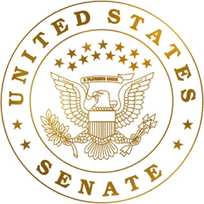
To: Senator Chuck Schumer
Senate Majority Leader, U.S Senate
Chairman Of the Ways and Means Committee
780 3rd Avenue, New York, NY 10017
From: Raian Khan
Subject: Support Inflation Reduction Act to Reduce Pandemic Inflation (H.R. 5376)

EXECUTIVE SUMMARY
Support the Inflation Reduction Act which allows for inflation of all goods to be reduced after a sharp increase following major disruptions to key supply chains and also strong consumer demand during the pandemic.

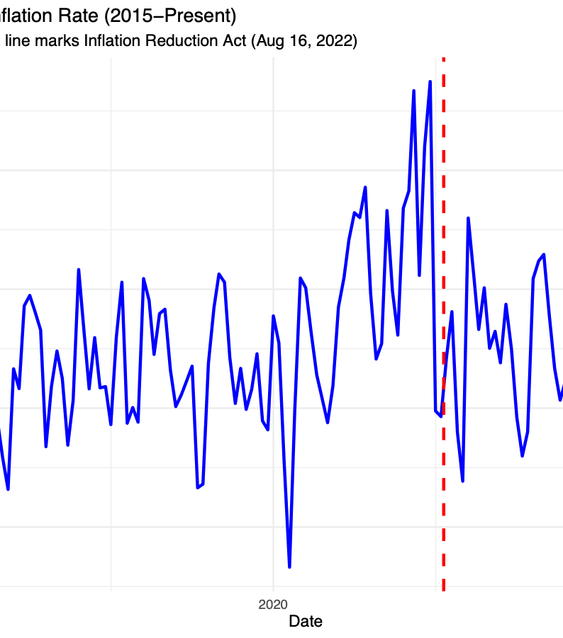
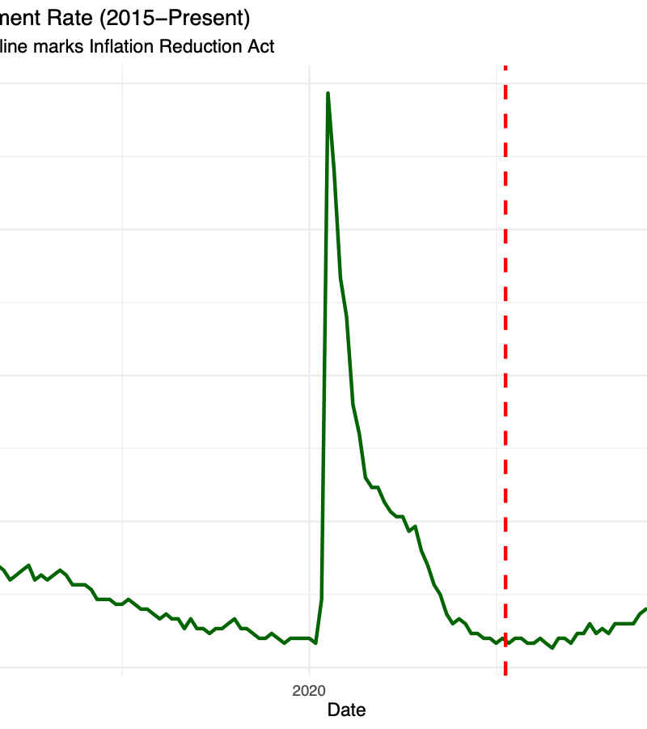
CONTEXT
The Inflation Reduction Act aims to reduce inflation following a growing demand from consumers and current global instability following this pandemic. Inflation has reached a decade high, while many households are experiencing a sharp increase in costs for food, gas, healthcare and other essentials that pressured current policy makers to respond to the growing rate of inflation. While unemployment was going down constantly each month inflation and everybody is returning to this new normal era, inflation was eroding all the income people were making and thus making purchase value of the dollar drop down heavily.

The Act plans address the issues of rising healthcare costs by letting medicare to negotiate prices for drugs thus lowering costs. It will also extend the Affordable Care Act. This legislation also states a 15 percent minimum corporate tax which is targeting to reduce the federal deficit for the next 10 years and by also . There are also introductions to investments in clean energy and funding many sorts of programs in regards to climate change. While inflation is controlled by mostly monetary policies, this act helps stabilize some of the fast rising prices and try to moderate the rate of inflation and even potentially bring it down.

The act is a very heavy climate focused bill essentially helping the people and also helping advocate for climate change. There are also other reforms that are being made in the tax code so that some of the budget coming from taxes can be made as investments into climate tax incentives and other climate programs.

These laws if supported can be beneficial to the American people as rising prices are always consistently an issue and must address it, especially during a pandemic where people can’t even afford what they want because all of a sudden prices just go up. While the monetary policies await change to attempt to further lower inflation, this law can have an immediate effect where it can moderate the inflation on some major aspects so the American people do not have to suffer from high prices from their hard earned income.

CONCLUSION
The bill that was originally introduced in the House of Representatives H.R 5376 by Rep. John Yarmuth not only attempts to lower prices and slow inflation on major things, reduce deficits to relieve pressure from inflation, but also a heavy advocate for investments in Climate programs. This act will help almost all Americans from pressure from inflation and unemployment stays at a record low, noting no effect on unemployment rates and potentially stimulate the economy more.

——————————————
U.S House of Representatives H.R5376 - Inflation Reduction Act:
https://www.congress.gov/bill/117th-congress/house-bill/5376/text

